TC-PM-007
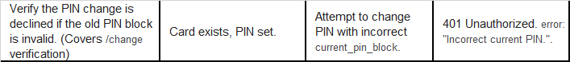
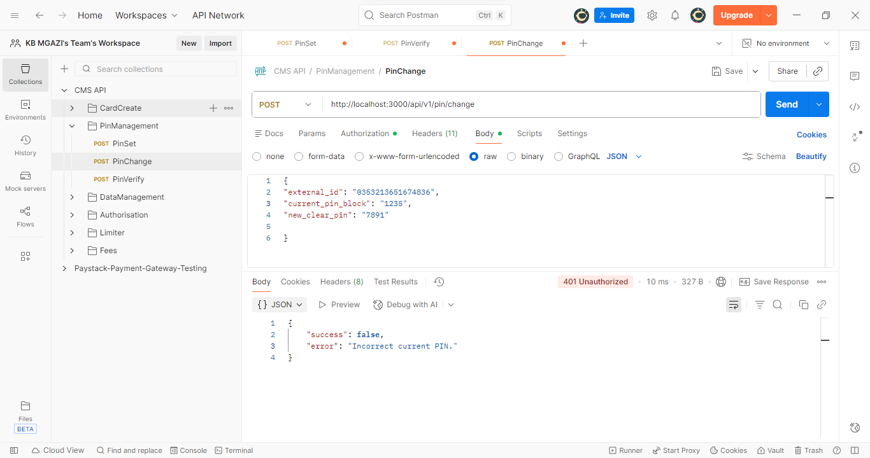
Request:
{
"external_id": "0353213651674836",
"current_pin_block": "1235",
"new_clear_pin": "7891"

}
Response:
{
"success": false,
"error": "Incorrect current PIN."
}

